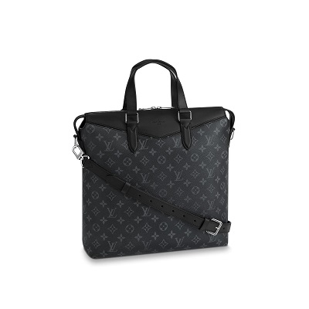

Tote Explorer Monogram Eclipse Canvas

PRODUCT DETAILS

**- Monogram Eclipse canvas**

**- Textile lining**

**- Epi leather & textile trim**

**- Silver coloured metallic pieces**

**- Zip closure**

**- Adjustable & removable leather shoulder strap**

**- Leather top handles**

**- Internal large flat pocket**

**- Internal three flat pockets**